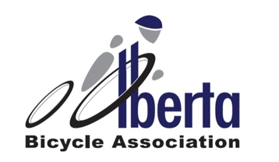

2024
Request for Upgrade

Please be advised that upgrade requests must be received no less than 7 days prior to the race for which the upgrade is being requested.

Name:
Coach Name:
Discipline:
Current Category:
Current Points:
Requesting Category:
Top 3 2022 Race Results:
Top 3 2023 Race Results:
Top 3 2024 Race Results:
Reason for wanting upgrade:

Road Racing Upgrade Policy

Cyclo-Cross Upgrade Policy

MTB Upgrade Policy

Track Upgrade Policy

